##### Which Browser has the fastest Search Speed

##### Aiden Kelly, Statistics, California Polytechnic State University

Abstract

(*This is where you provide a short one-paragraph description of the study overall: a very brief discussion of the research question, materials and methods, and findings. Best to write the abstract once you have finished writing the entire article. Should be no longer than 12 to 15 lines.)*

1. Introduction

(*This is where you should describe your research question/goals and motivation. Your motivation should address why you are interested in the answers to your research question, and why the reader should be interested in your research. You should also cite at least two other research articles or articles in popular media that are related to your research question. Discuss how the content of these articles is similar and/or different from what your study is about. Did you have an interest in finding which treatment combination is “best”? What did you expect to find? You should break this section up into at least 2 or 3 paragraphs.*) This is sample text and needs to be completely replaced before submitting your paper.

2. Materials and Methods

(*In this intro to this section, you will provide details on the data collection process. Such as, where, when, how did you find the experimental units and collect the data? Were there any potential measurement issues? Did you need to change anything from what you proposed to do do in the project protocol form; e.g. changed the levels of any particular factor, etc.? Are there any definitions the reader should be aware of? Make sure it is clear how the reader could generate the data for herself or himself. This section should have enough details that the reader should be able to replicate the data collection procedure just by reading this section. Did anything go wrong during data collection? If you have any pictures from your experimental setup and your data collection phase - this is the section to include those pictures. Before you get into the details in the subsections, write a short overview of the protocol you followed; eg. what day and time did you carry out the data collection, what equipment was needed, where did you get the materials, etc.*)

2.1 Treatment Structure

(*This is where you describe your treatment structure, factors of interest and their levels, and treatments. It is recommended that you provide some motivation for why you chose these specific levels of the factors.* )

2.2 Response Variable(s)

(*This is where you describe your response variable(s), how it (they) were be measured, what the units of measurement were, whether you were aiming for the values of the response variable to be high or low.)*

2.3 Experimental Unit

(*This is where you describe your experimental units and how they were acquired. Any inclusion/exclusion criteria that were used to select them should be discussed.*)

2.4 Design Structure

(*This is where you describe your design structure – whether CRD or RCBD; if RCBD what the blocks are. Describe how random assignments of treatments to experimental units was carried out, how much replication there was, and if there was blocking, what the motivation was for using blocking. Discuss how you decided on the number of replicates.*)

2.5 Dealing with other sources of variation

(*This is where you describe how you used direct control and randomization of run order to tackle sources of variation other than the factors of interest. Were there any measurement issues or other issues during data collection? Include any diagrams/pictures to help your reader understand and visualize the data collection process.*)

2.6 Statistical model and data analysis

(*This is where you describe the Effects model for your analysis, describing each term in the context of the data, what values the different subscripts take, and all assumptions made by the model. Describe how you analyzed the data – software used (most likely JMP with version number), statistical model used (most likely ANOVA), whether any factors needed to be specified as random. Include the FWER that you will be using.*)

*(As you wrap up this section, you should have made sure that your reader understands exactly WHAT you did, HOW you did it, and WHY you did it. Your reader should be able to replicate your protocol exactly. If they cannot, you’ve left out important details.)*

3. Analysis and Results

(*In this section, you will provide your findings from the study. Remember to sprinkle in graphs and tables throughout this section. Be sure that all graphs and tables are numbered and labeled. The labels should be descriptive so that they can stand on their own without any supporting text.*)

3.1 Descriptive statistics

(*This is where you include preliminary discussion of comparison of treatments, based on plots of data. Graphs to consider include side-by-side boxplots, main effect plots, and interaction plots. Be sure to discuss the information the graphs convey. What should the reader be able to take away from these graphs? If you have more than one response variable, you should include a separate discussion for each response variable.*)

[EXAMPLE] Figure 3.1: Side-by-side boxplots showing how flight time changed with changes in wing length and whether or not foot of helicopter was weighted

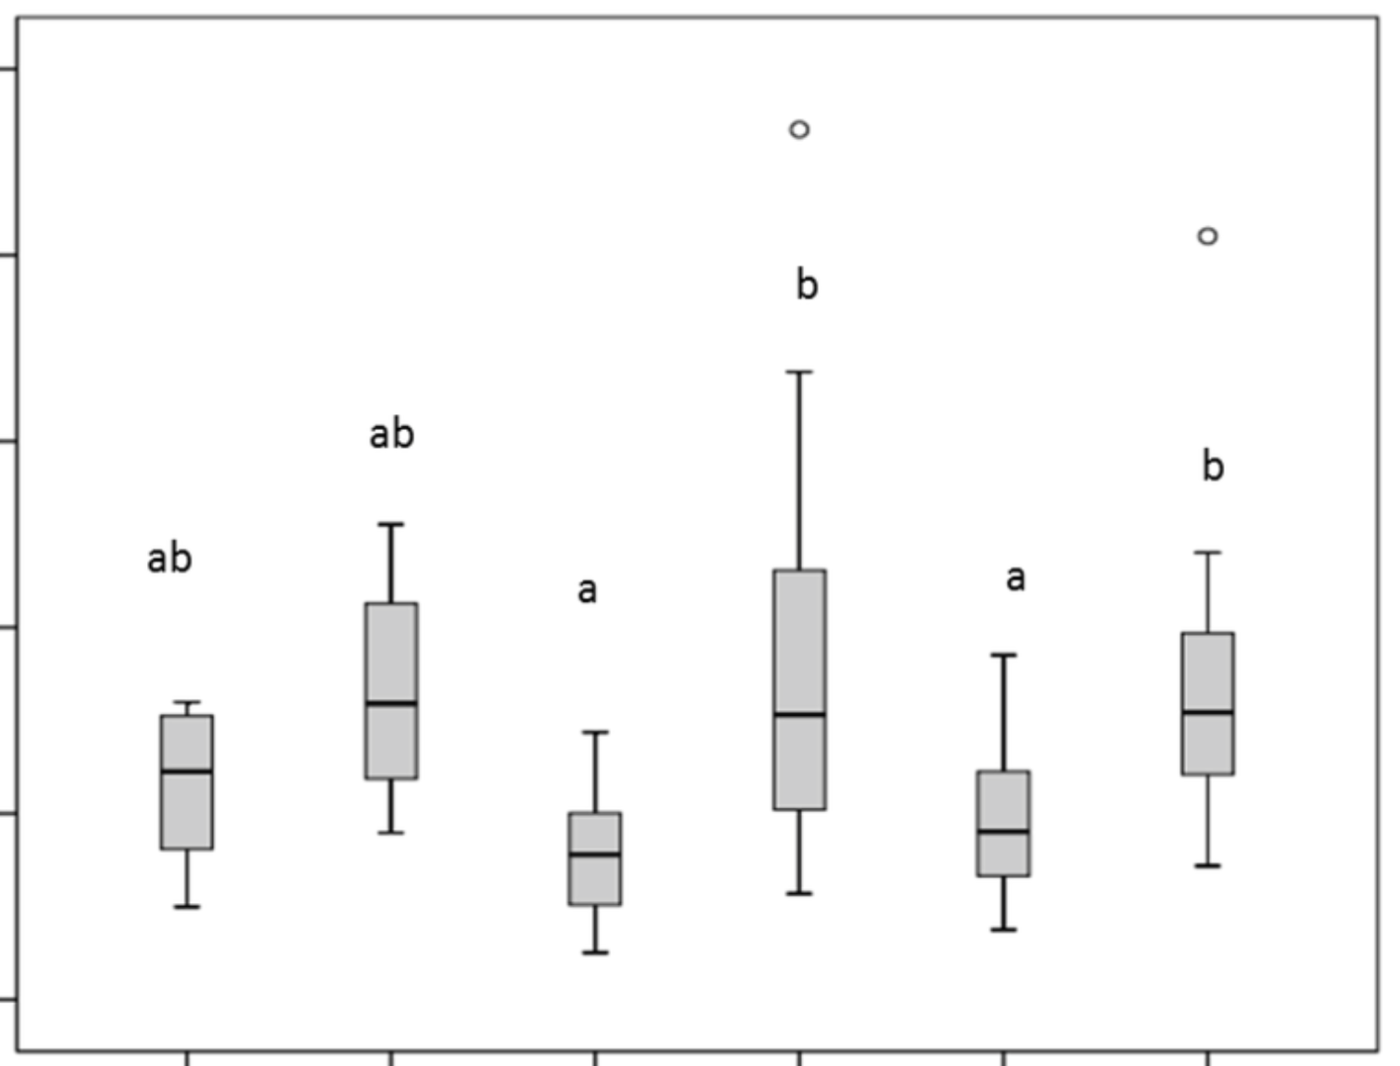

3.2 Inferential findings

(*This is where you include results from ANOVA, and multiple comparisons etc. Be sure to discuss whether the ANOVA assumptions were met, and how you verified whether assumptions were violated. You should discuss which effects – interaction effect and /or main effects – were found to be statistical significant. Cite p-values. State findings in the context of the study. Include tables of means and SDs (or SEs) just like you did for project 1 report. Where relevant include the results of Tukey comparisons (letters). Discuss the content of the tables. How do they help answer your research questions? Address the contrasts you proposed to address in your protocol form. Be sure to address how you adjusted for multiple testing.*)

[EXAMPLE] Table 3.1: Mean (± SE) flight time (seconds) for Wing length * Weight combinations

| Winglength | Weight | Mean | SE |
| --- | --- | --- | --- |
|  |  |  |  |
|  |  |  |  |
|  |  |  |  |
|  |  |  |  |

Note: Levels that share a letter have means that are not statistically significantly different.

[EXAMPLE] Table 3.2: Mean (± SE) flight time (seconds) for Wing length

|  |  |  |  |
| --- | --- | --- | --- |
| 2 inch |  |  |  |
| 3 inch |  |  |  |

Note: Levels that share a letter have means that are not statistically significantly different.

[EXAMPLE] Table 3.3: Mean (± SE) flight time (seconds) for Weight

|  |  |  |  |
| --- | --- | --- | --- |
| Weighted foot |  |  |  |
| Unweighted foot |  |  |  |

Note: Levels that share a letter have means that are not statistically significantly different.

(*As you wrap up this section, ensure that you have answered all your proposed research questions, including any contrasts that you had proposed exploring, that you have provided the tables of means and SD, p-values, etc. to support your answers, as well discussed what the various entries in the tables are.*)

4. Conclusion

(*In this section, you will provide the main findings of your study – one more time. This time you do not need to provide all the numbers to support your findings, but more “big picture” conclusions. For example, “we found strong evidence that helicopters with 3inch wing length have a higher average flight time than those with 2inch wing length.” Etc. This is your last opportunity to make sure your reader understands your take-home message. Which treatment combination was “best”? Which treatment had the largest effect? Smallest? Answer all of your research questions one more time.)*

5. Next steps

*(In this section you will provide suggestions to improve the study if it were run again. Were there issues you would address if the experiment was done again? Variables which should have been controlled, but were not? Data collection issues that caused problems? Etc.)* This is sample text and needs to be completely replaced before submitting your paper.

*(What would be an interesting follow-up experiment? This experiment should have sparked some interest in future research. Provide at least one example of a direction that others could go to follow-up on what you’ve already done.* This is sample text and needs to be completely replaced before submitting your paper.

References

(Please verify that all references are included. Especially the ones you were asked to include in the Introduction. If it’s a weblink, include the date the link was last accessed.)

* Author names (year of publication), “Name of article” *Journal name,* volume, pages …
* Author names (year of publication), “Name of article” *Journal name,* volume, pages …

Appendix

* Start on new page
* Put ALL JMP output (that you used, including Output from Randomization scheme from JMP that was used to carry out random assignment of treatments to experimental units, ANOVA results, Tukey comparison outputs, residual plots to assess whether any ANOVA assumptions had been violated. Etc.) in the appendix - You should have all output here in case your reader has a question about where a number/conclusion/decision came from in the software output, then they can look it up here.

Requirements for this written report:

* Maximum length (not including Appendix): Two pages (that is 4 sides); Appendix length is not included.
* Keep the font at 11pt Times New Roman, with single spacing.
* Maintain the two-column format of this template with the font and the section headings and breaks
* Make sure that tables and figures don’t get chopped off and always appear with a number and descriptive title. When you describe the content of a table or figure, refer to the table/figure by its number. For example, “*As can be seen in Figure 2.1, …*”
* Provide a descriptive title for your manuscript
* DO NOT put any JMP output (other than graphs) into the main write-up (except in the Appendix); all tables should be created from scratch.